Assignment 1

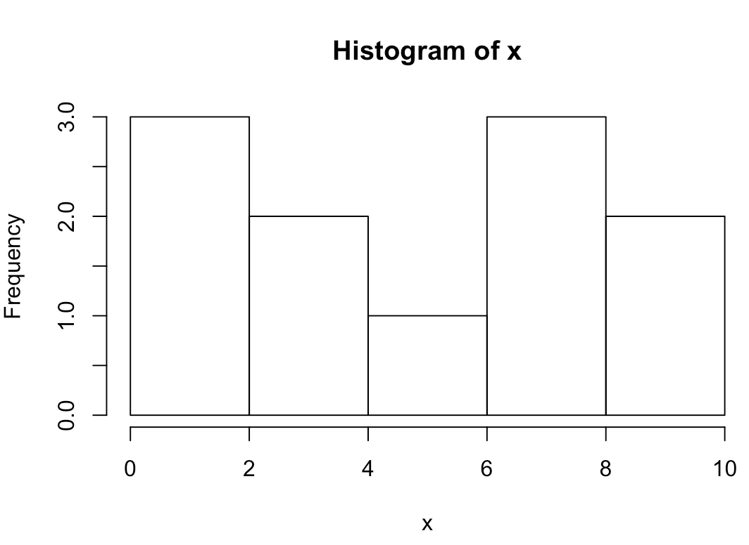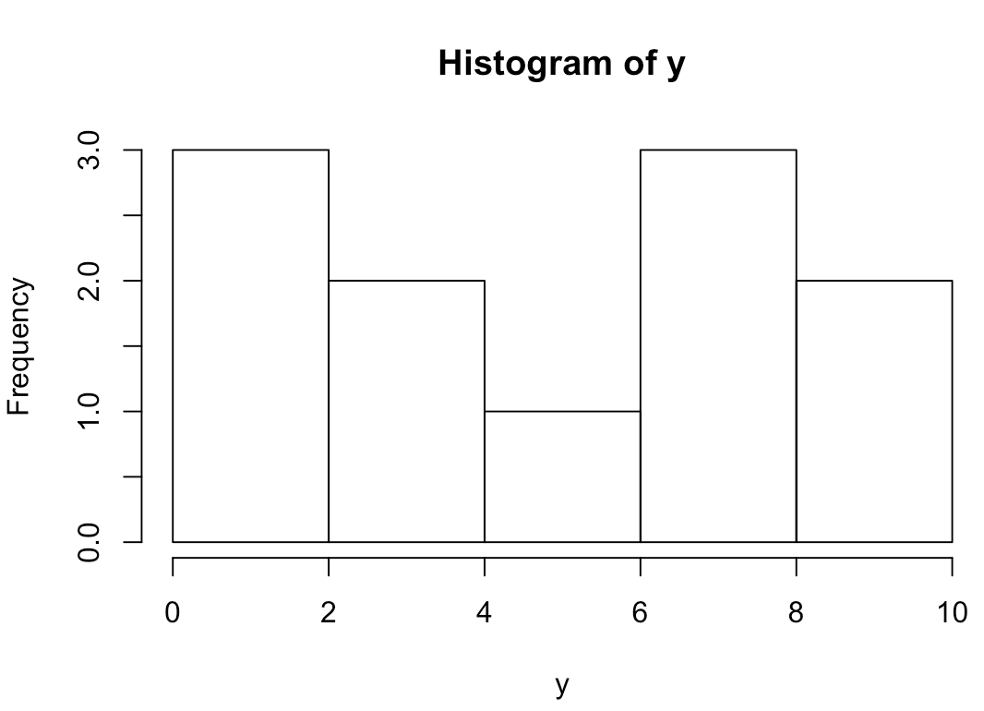

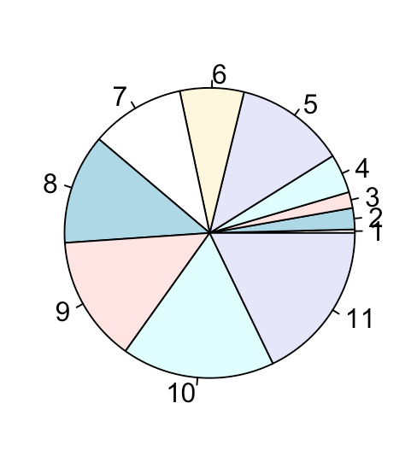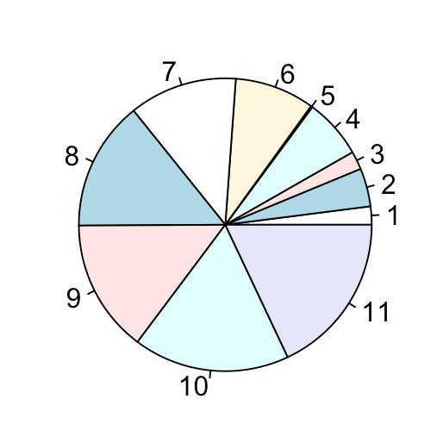

Y

X

The histograms of X and Y are exactly the same. Similarly, they show that they both have double peaked distributions at 0-2 and 6-8. The pie charts show the individual distribution for each X and Y value on their respected pie charts.

Y

X

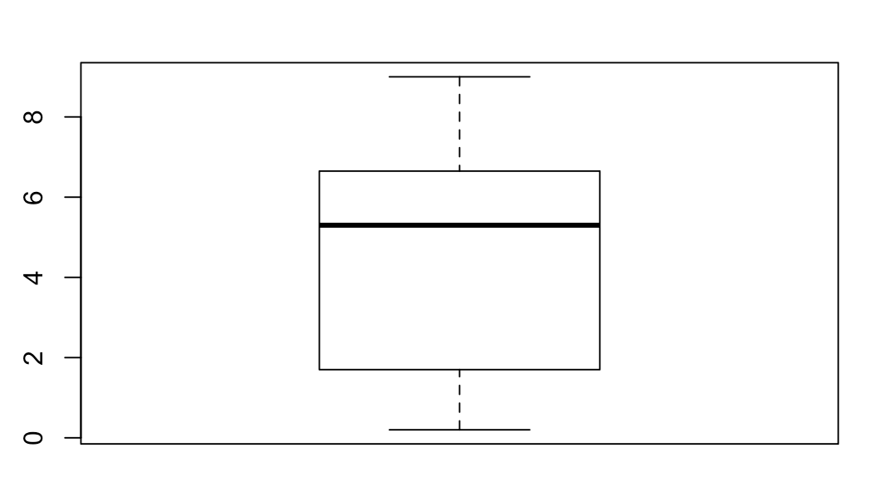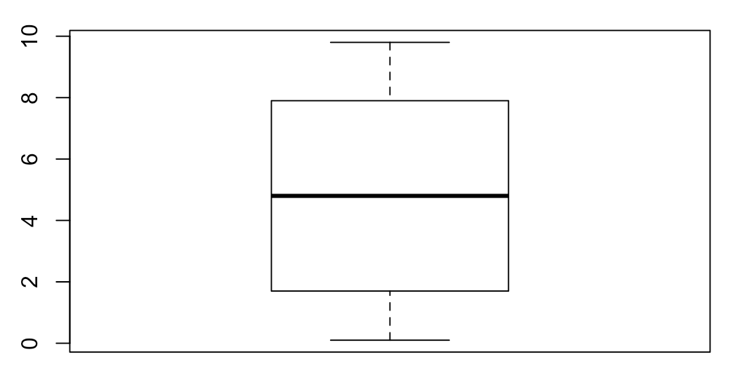

Min: 0.1

Q1:1.7

Median:4.8

Q3:7.9

Max:9.8

Min: 0.2

Q1:1.7

Median:5.3

Q3:6.65

Max:9

There are no outliers for X and Y.

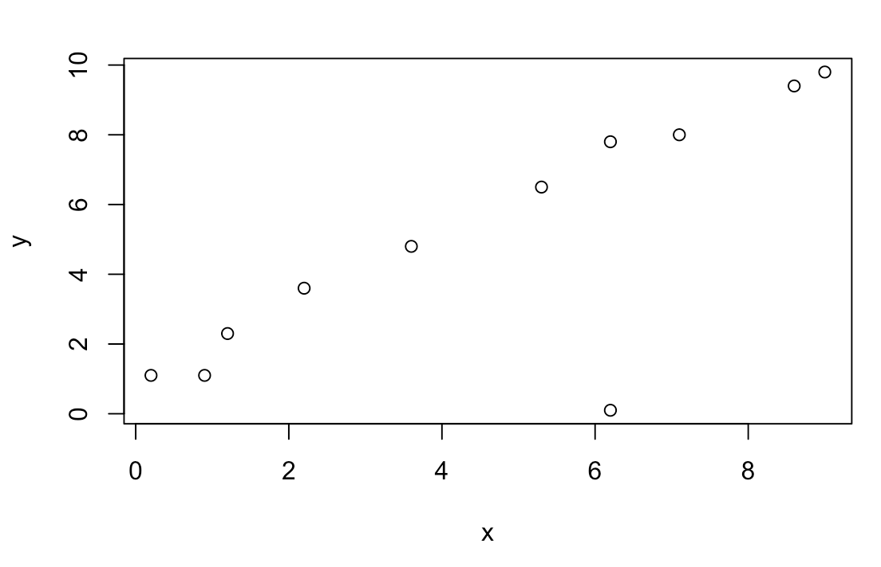

Correlation coefficient: 0.792342

There is a positive linear association between X and Y. This is because since the correlation is greater than 0 and that X and Y both increase, we can conclude that there is a positive linear association.

1. There is one outlier on the scatter plot and that is point (6.2, 0.1).

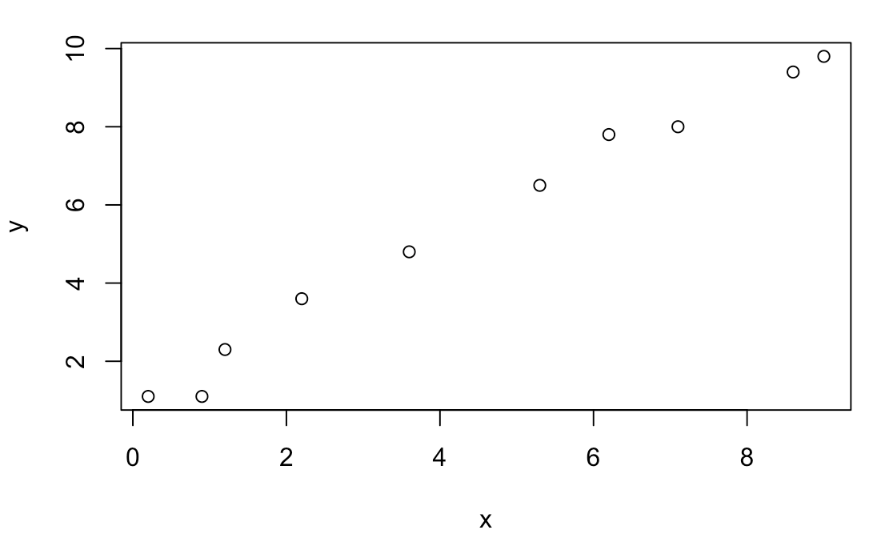

Correlation coefficient: 0.9932443

1. Between iii. and iv., the biggest difference that I observed was that iv. has a higher correlation coefficient. Thus, iv. has a more positive linear association than iii. This is because there on iii. There was one outlier that played a major role when computing the correlation coefficient, which is heavily shown between iii. and iv..